Name: miles wendler
CSE 212 Data Structure “Cheat Sheet”

Note: This document should contain your own work. It is a violation of the BYU-Idaho honor code to share this document or copy in whole or in part from another.

Data Structure | Graphic | Purpose and Example | Time Complexity of Common Operations
 |  |  | Insert | Access
Dynamic Array | 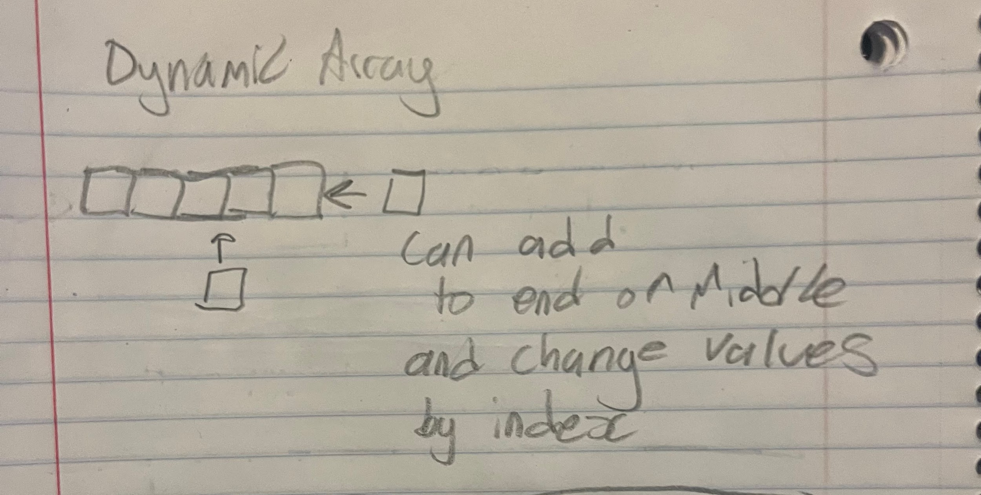 | That funny language people would attempt to speak as kids pig latin. You could take any string and add the characters after the first one to a new one, and then add at the end the first one. Then you could add two more chars to the end “ay” | At the beginning:O(n)  At the end:O(1) | Find by value:O(n)  Find by index:O(1)
Linked List (Doubly-linked) | 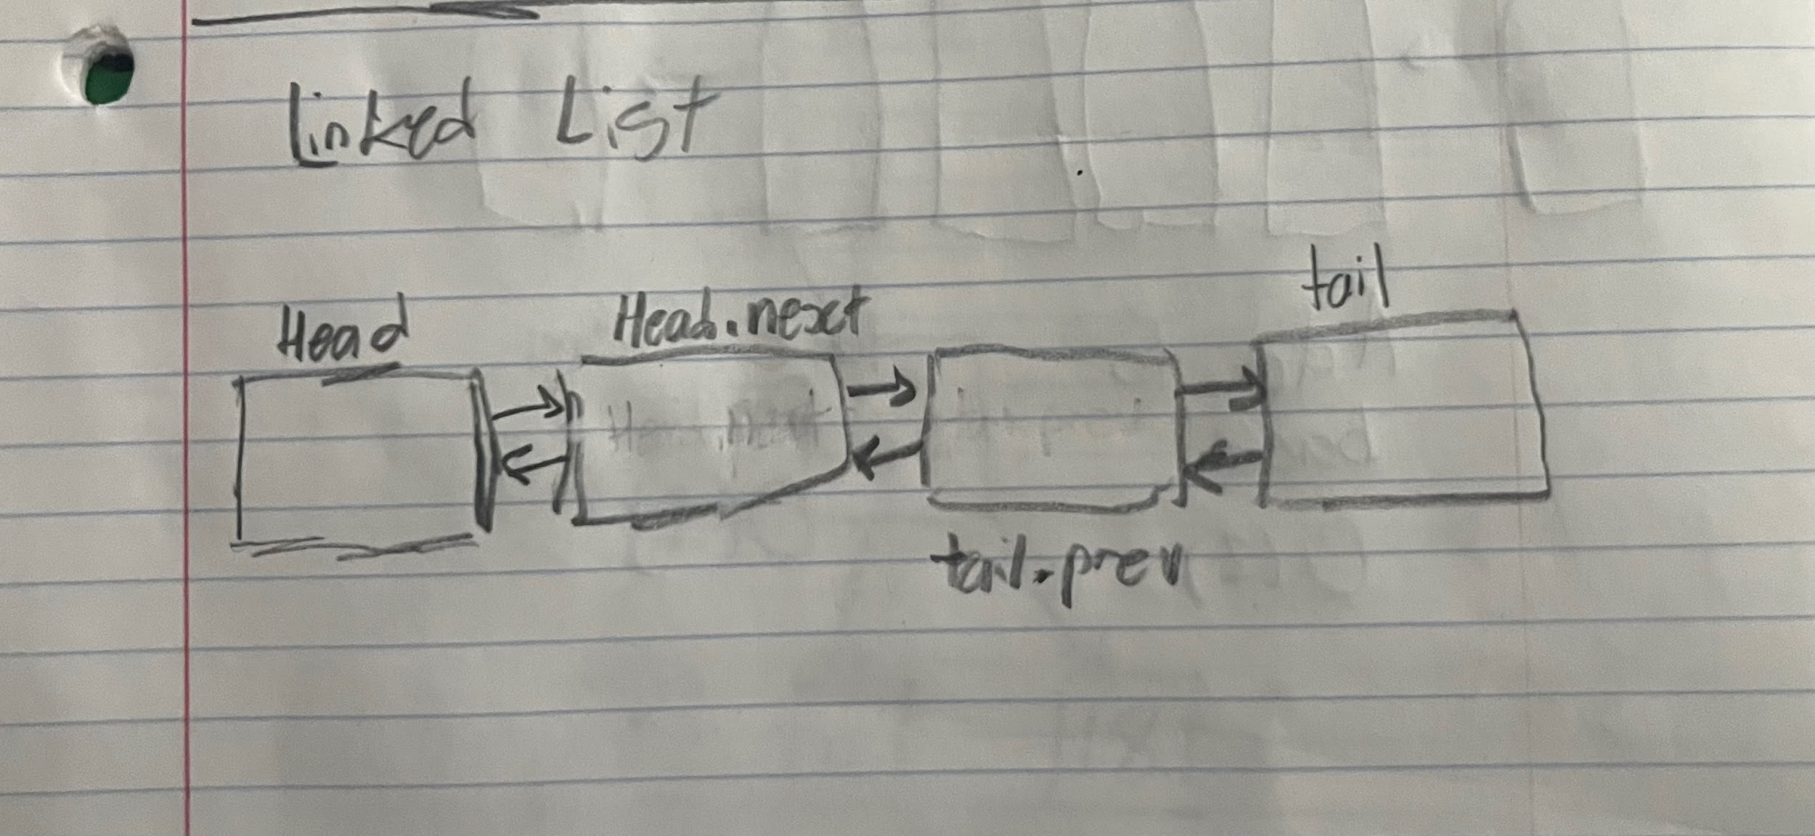 | An array that you can insert and take one to length-1 variables in between any other variables. For example a scoreboard, lets say someone jumped from second last to second place, it would be the same time complexity of doing last to first. | At the beginning:O(1)  At the end:O(1) | Find by value:O(n)  Find by index:O(n) (with an option to search back to front/front to back)
Stack | 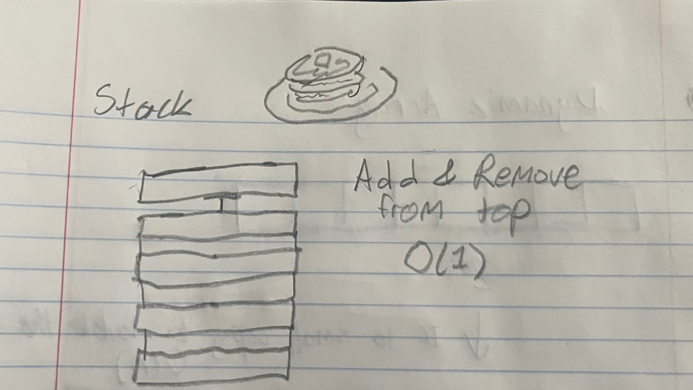 | An array that you usually only use to take and add the most recent variable. Those ball sorting games where theres towers and you can only take from and add to the top you could use a stack. I remember for highschool coding project we used stacks to solve tower of hanoi recursively. | The top: O(1)  The bottom: O(n) | The top: O(1)  The bottom: O(n)
Queue | 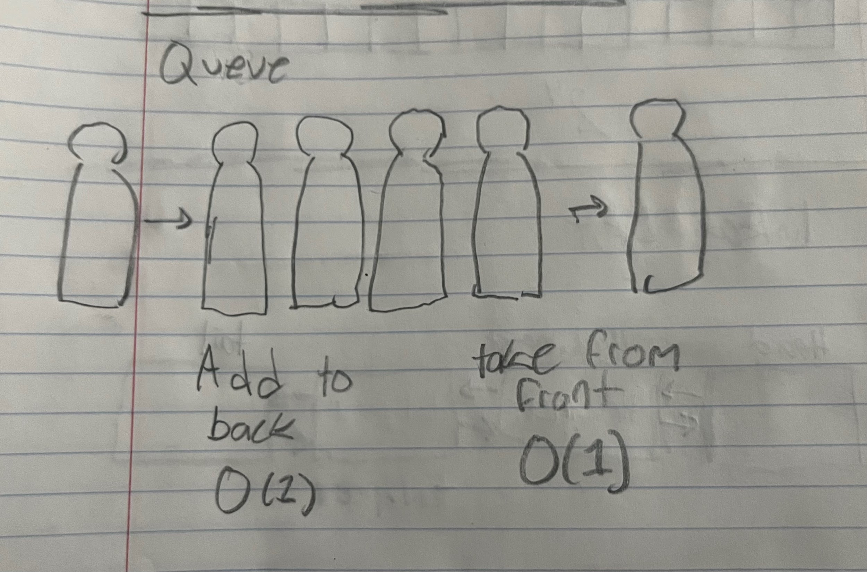 | An array you take from the front and add to the back easily. In Kenshi you can change the order one of your guys crafts certain things. Clicking any item adds it the last thing he will do. And he will always complete the first item. | The Front: O(n)  The Back: O(1) | The Front: O(1)  The Back: O(n)
Map | 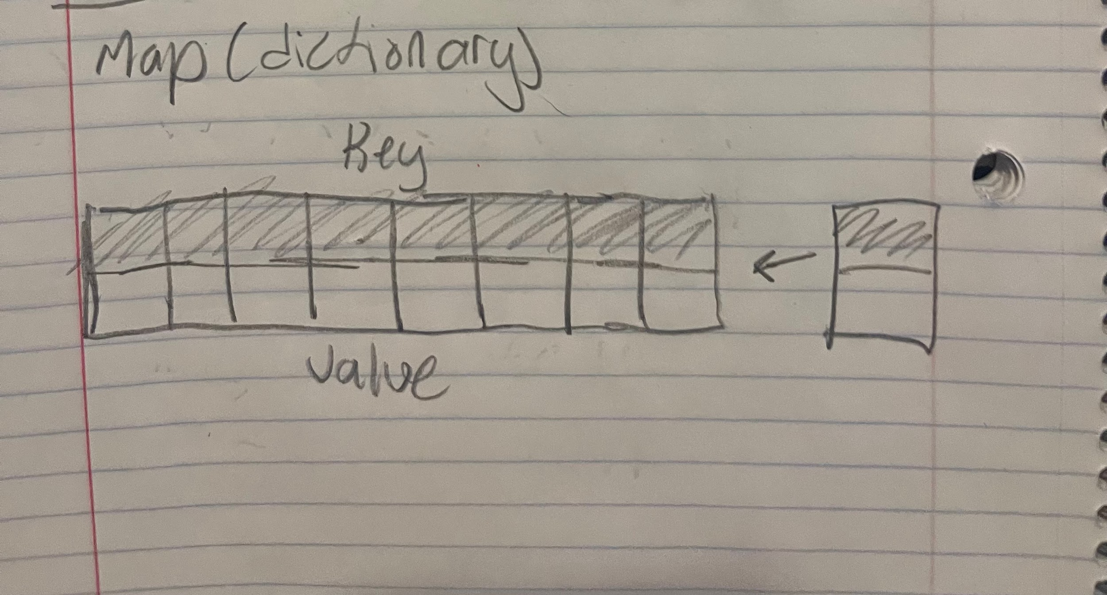 | An dynamic array with the option of two types of variables, and the ability to access one pair with either. For example in a detailed shooter game you could keep track of the amount of bullets you have in each magazine. And when you reload without using all your bullets you will be punished for that later, or at least be forced to adjust the magazines you use based on encounters. | The front:O(1)  The back:O(n) | index:O(1)  Value: O(1)
Balanced BST | 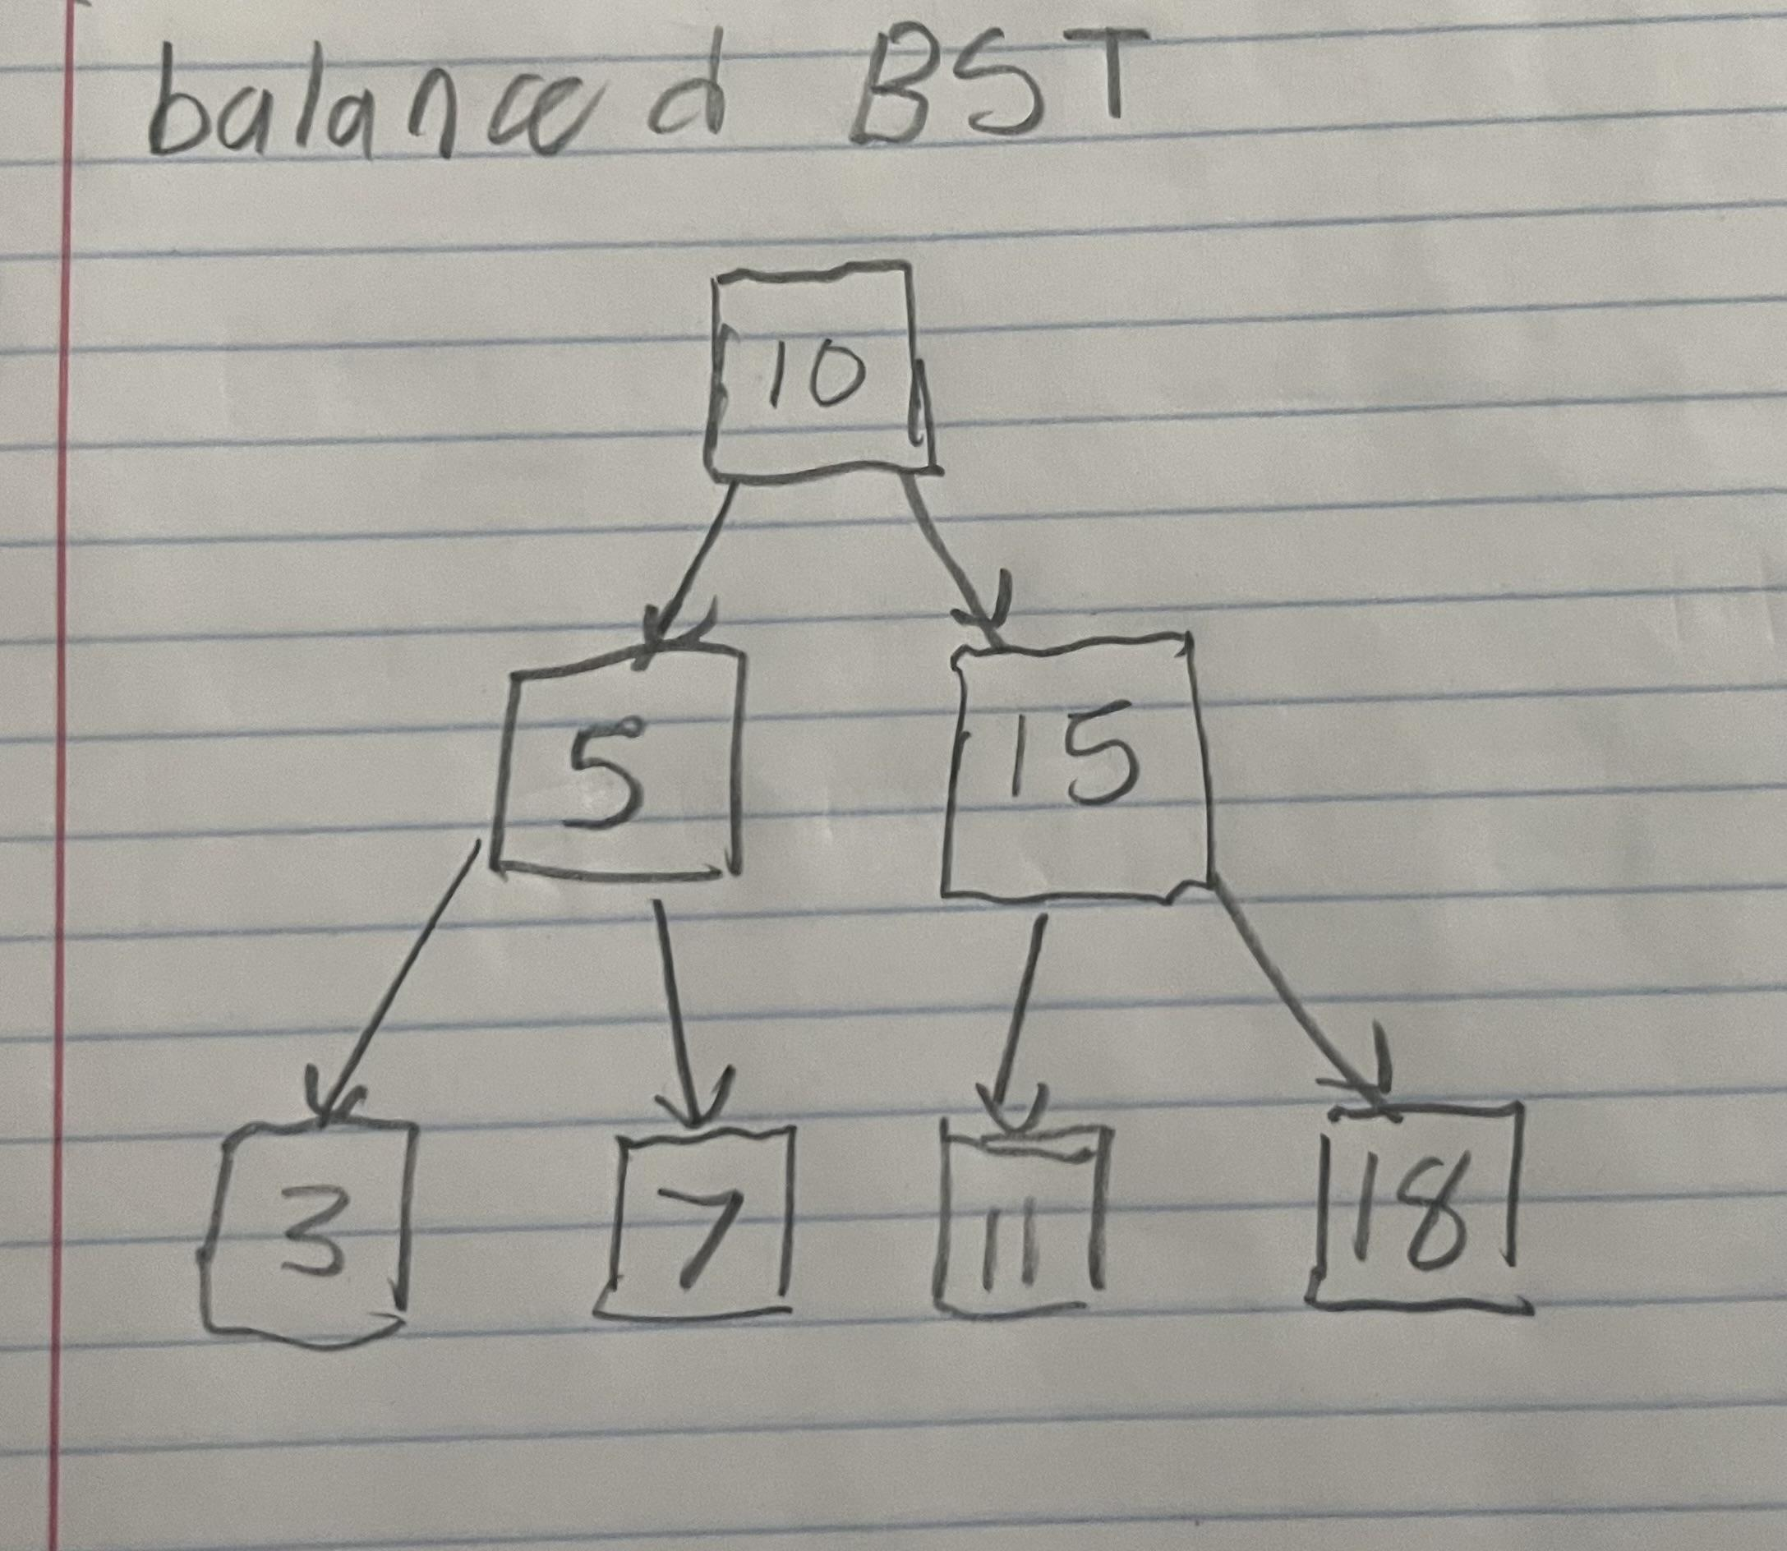 | A linked list with two .next's titled left and right. The values to the right are greater than current and the values to the left are less than current. In order to be balanced the difference in tail lengths has to be less than 3. You could use this to make a list of greater and less than strings. | O(log n) | O(log n)

